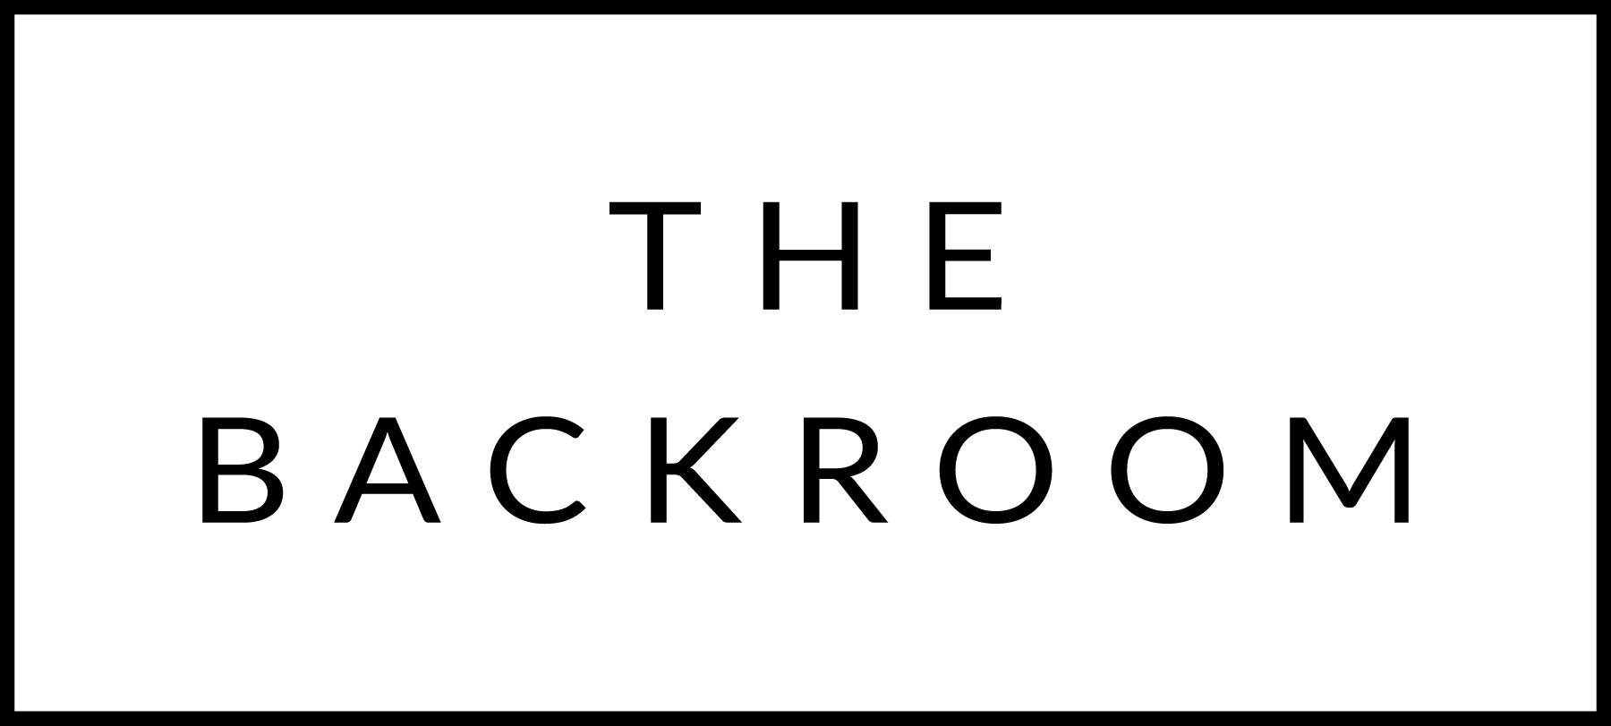

November 24th, 2017

COCKTAIL HOUR SNACKS
Jasper Hills Fondue
Roasted Broccoli, Potatoes, Pepperoni, 7-Grain Bread

FIRST
Root Vegetable & Turkey Ramen
6 Minute Egg, Thai Basil

Steininger Gruner Veltliner, Kamptal, Austria 2015
By the glass: $10, By the Bottle: $49

THE MAIN EVENT
Roasted Chatham Cod
Braised Red Cabbage
Almond & Pomegranate Brown Butter

Pierre Chermette Beaujolais, France 2015
By the glass: $8, By the bottle: $40

FOR THE TABLE
Rutabaga Tempura
Anchovy Aioli

DESSERT
Cinnamon French Toast
Sweet Potato

