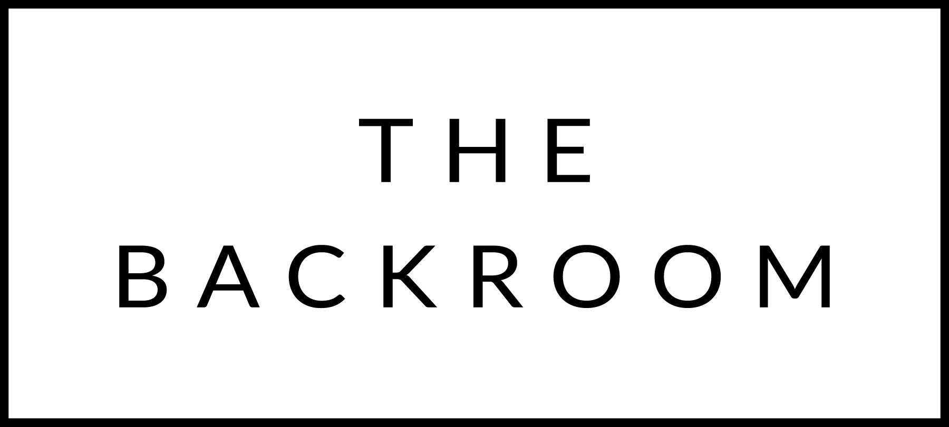

December 8th to 10th, 2017

COCKTAIL HOUR SNACKS
Pork Belly Summer Rolls
White Anchovy & Pepper Toast
Chicken Liver Pate
Scotch Eggs

FIRST
Seared Diver Scallops
Grilled Cabbage, Roasted Beets

THE MAIN EVENT
Local Strip Steak
Bubble & Squeak
Smoked Bernaise

FOR THE TABLE
Sweet & Sour Collard Greens

DESSERT
Cardamom & Blood Orange Donuts

