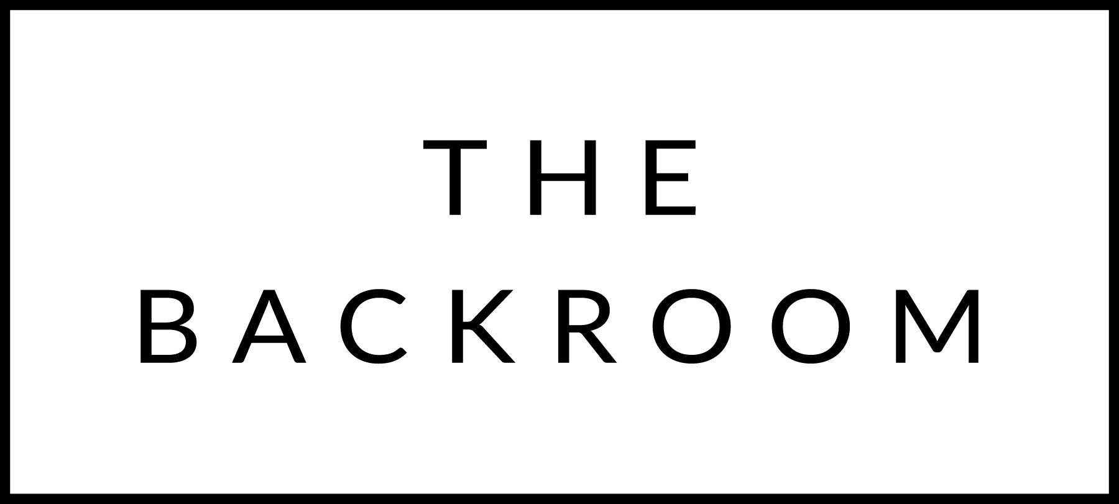

December 9th & 10th 2016

COCKTAIL HOUR SNACKS
All Souls Tacos
Chicken Mole, Venison Tamarind & Chili,
Chatham Cod

FIRST
Maple Brook Burrata Salad
English Muffin Croutons, Pickled Onions

THE MAIN EVENT
Braised Short Rib
Pomegranate, Walnuts & Parsnip

FOR THE TABLE
Shaved Brussels Sprouts
Brie & Cranberries

DESSERT
Vanilla Buttermilk Panna Cotta
Chai Poached Pears, Oat Cookie Crumble

