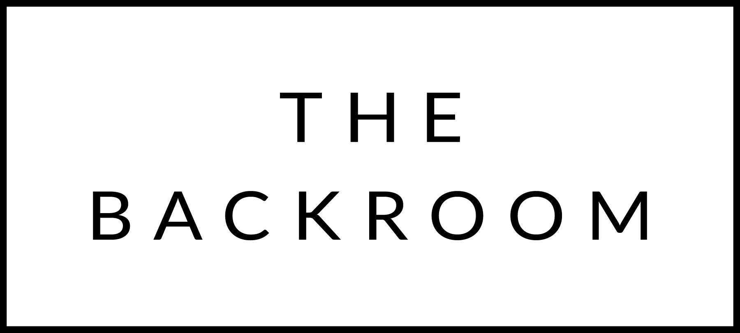

Whiskey
(2 Finger Pours)

Scotch
Johnnie Walker Red Label (Scotland) $8
Johnnie Walk Black (Scotland) $10
The Macallan 12 (Scotland) $14
Laphroaig 10 (Scotland) $11
Lagavulin 16 (Scotland) $18
Glenlivet 18 (Scotland) $22
Glenmorangie 10 (Scotland) $10
Highland Park Single Malt (Scotland) $11
Bruichladdich Barley Whiskey (Scotland) $12
Japanese Whisky
Suntory Whiskey HIbiki 12 (Japan) $15
Nikka Taketsuru Pure Malt (Japan) $14
Yamazaki 12 Single Malt (Japan) $18
Rye
Bulleit (Kentucky)$9
Whistlepig 100-100 (Vermont) $15
Whistlepig Old World (Vermont) $22
Mad River Rye Whiskey (Vermont) $12
Bourbon
Makers Mark (Kentucky) $9
Blantons Single Barrel (Kentucky) $13
Silo Bourbon (Vermont) $15
Bulleit Bourbon (Kentucky) $9
Hudson Baby Bourbon (NY) $16
Woodford Reserve (Kentucky) $9
Woodford Reserve Double Oaked (Kentucky) $12
Jeffersons “Aged at Sea” $18

Coffee Shots
$6 Each

Jameson
Grand Marnier
Baileys
Amaretto
Sambuca
Drambuie
Frangelico
Sortilage (Maple Liqueur)
Kahlua
Snap
Root
Sapling Maple Liquor

Sweet Wines
Six Grapes Port $6
Eden Heirloom Apple Ice Cider 375Ml $45
Grahams 20 Year Tawny Port $15
Newhall Farm Ice Cider 375ML $54

Digestif
$8 Each
Lillet
Fernet Branca
Jaegermiester
Campari
Aperol

