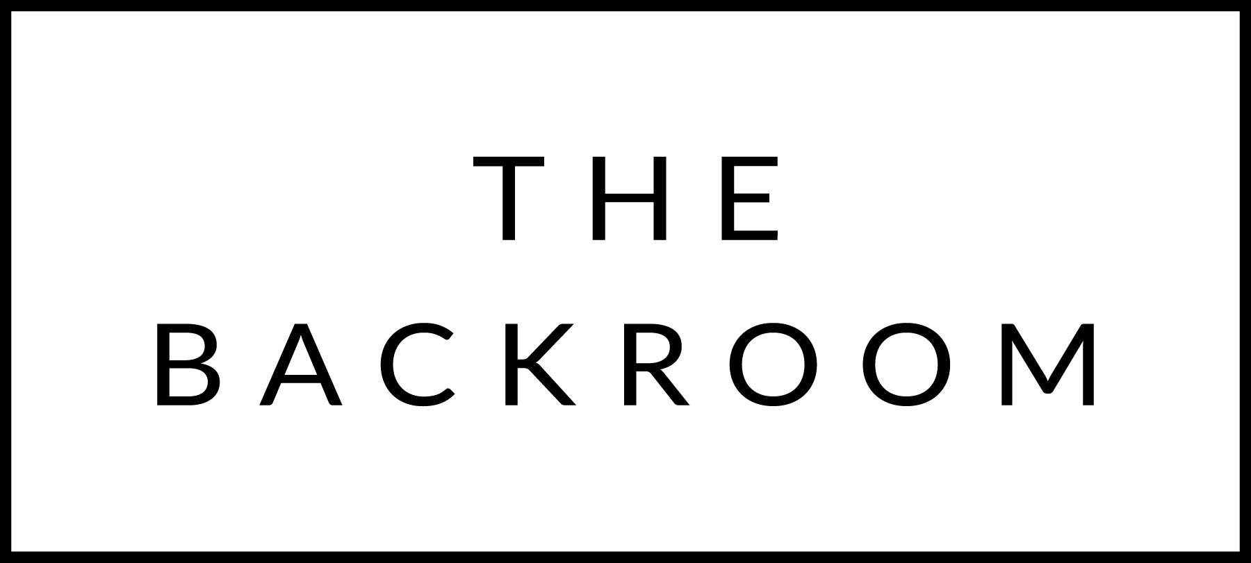

January 12th-16th, 2017

COCKTAIL HOUR SNACKS
Sesame Salmon Tartar, Scallion Pancake
Duck Liver Mousse, Lingonberry
Local Feta, Maple & Zatar

FIRST
Maple Wind Farms Pork Posole
Cilantro, Avocado, Onion

THE MAIN EVENT
Roasted Beef Sirloin
Creamed Spinach Stuffing
Parsnips & Balsamic Onions

FOR THE TABLE
Roasted Rutabaga
Brown Butter, Soy & Maple

DESSERT
Butterscotch Budino
Whipped Crème Fraiche, Rosemary Shortbread

