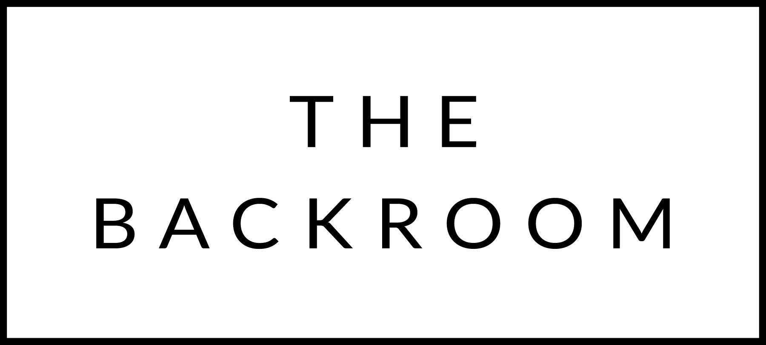

November 23nd, 2017

COCKTAIL HOUR SNACKS
Jasper Hills Fondue
Roasted Broccoli, Potatoes, Pepperoni
7-Grain Bread & Dates

FIRST
Kale Salad
Chorizo Vinaigrette & Aged Cheddar

THE MAIN EVENT
Misty Knoll Turkey
Roasted Breast, Braised Thigh, Osso Bucco & Wings
Cranberry Sauce, Stuffing & Gravy

FOR THE TABLE
Brussels Sprouts & Bacon
Passion Fruit Glazed Sweet Potato
Boursin Creamed Kale
Crushed Potatoes, Caramelized Leeks

DESSERT
Pumpkin or Apple Pie

Steininger Gruner Veltliner, Kamptal, Austria 2015
By the glass: $10, By the Bottle: $49

Pierre Chermette Beaujolais, France 2015
By the glass:$8, By the bottle: $40

