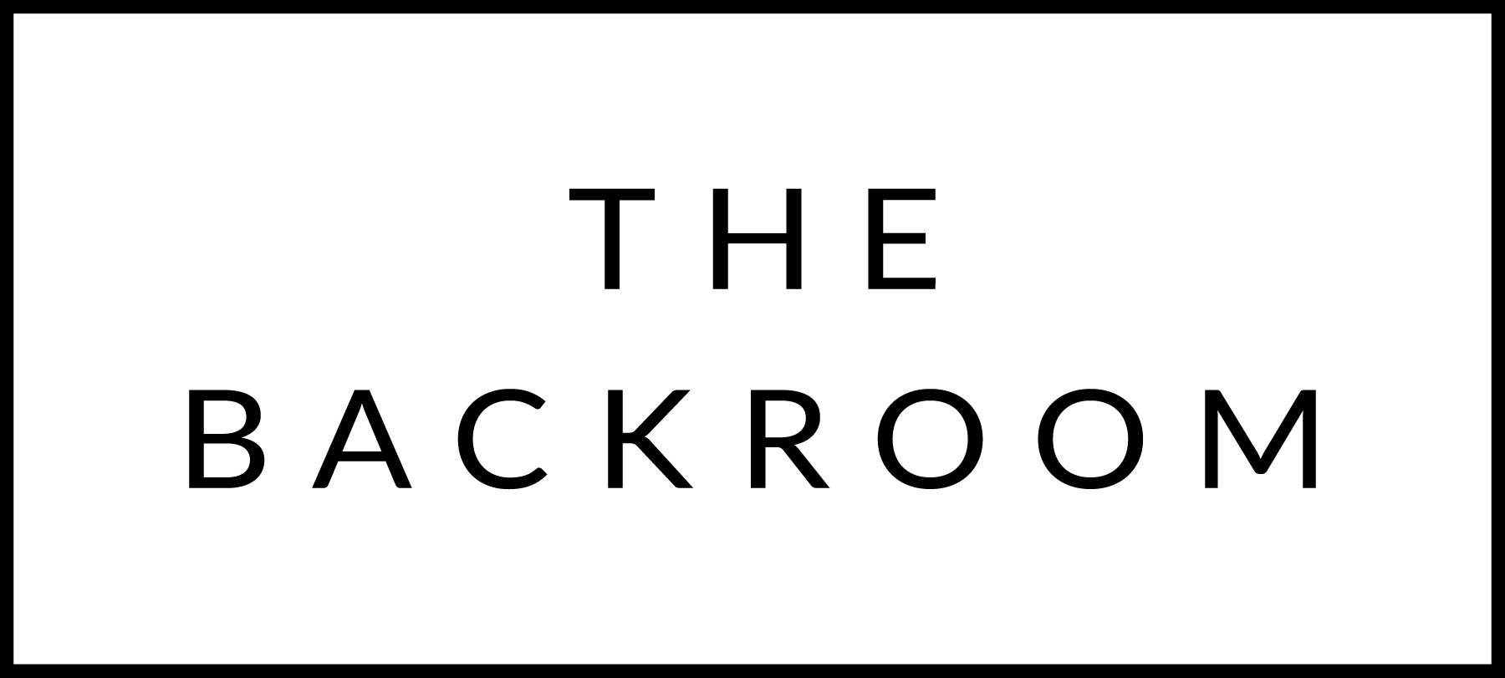

November 26th & 27th 2016

COCKTAIL HOUR SNACKS
Dips & Spreads
Turkey Liver Pate, Cod Brandade,
Blue Cheese Mousse, Zucchini Hummus

FIRST
Smoked Turkey Pho
Thai Basil, Rice Noodles & Kohlrabi

THE MAIN EVENT
Bacon Wrapped Filet Mignon
Sauteed Mushrooms, Red Onion & Herb Jam

FOR THE TABLE
Thanksgiving Pasta Gratin

DESSERT
Coconut Ice Cream Sandwich

