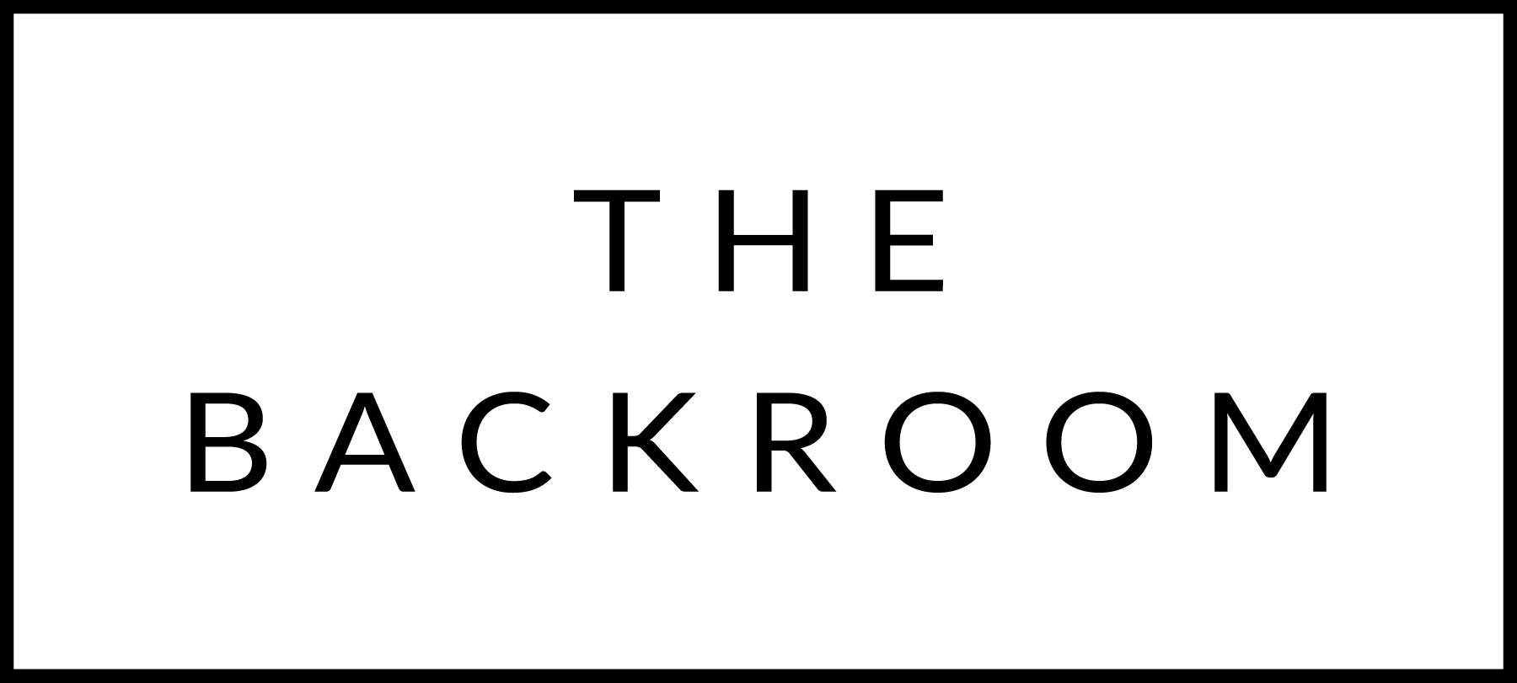

Happy Birthday, Sarah!
November 29th, 2015

COCKTAIL HOUR SNACKS
Salmon Rillettes, Truffle Spinach Dip
Turkey Liver Pate
Bread & Crudites

TO START
Farro Penne Rigate
Cabbage, Crème Fraiche, Truffle

THE MAIN EVENT
Slow Roasted Boyden Farms Ribeye
Celery Root Puree, Porcini Bordelaise

FOR THE TABLE
Kale & Barley Almondine

DESSERT
Pumpkin Brioche Bread Pudding
Brown Butter Ice Cream

