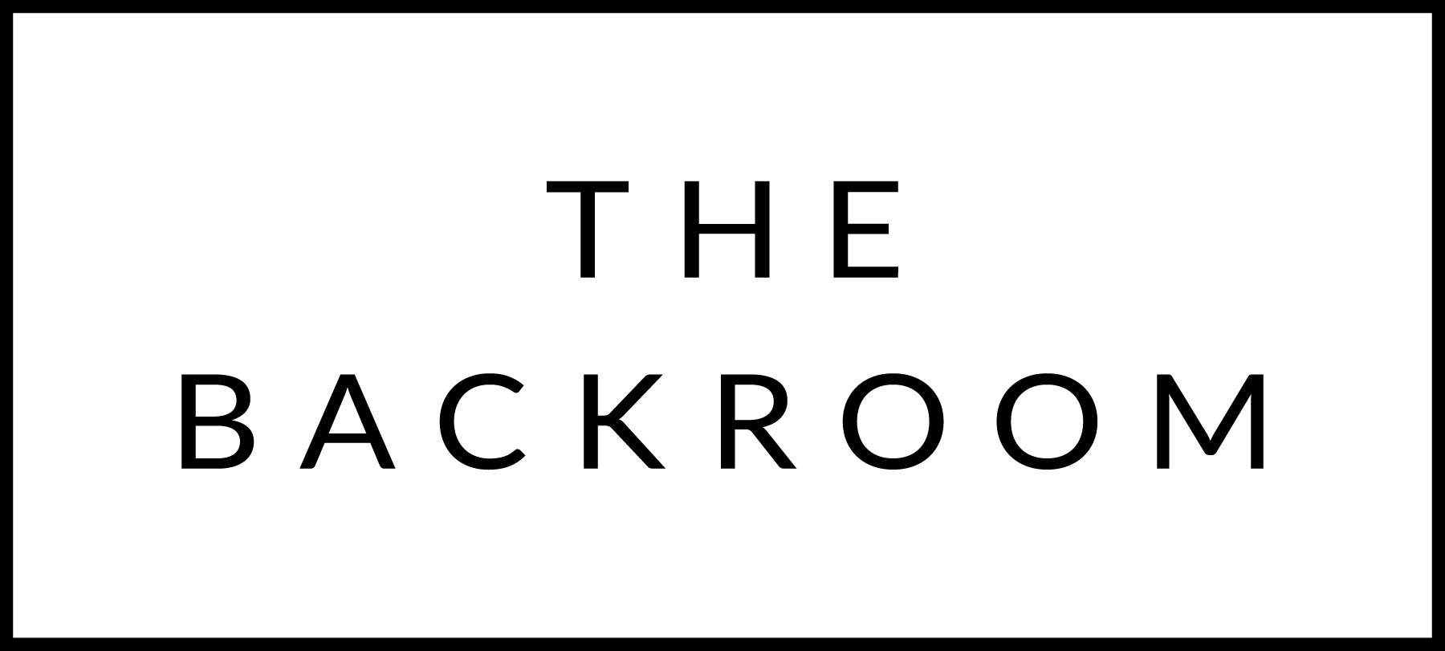

December 10th, 2015
Sugar Bob’s Holiday Party

COCKTAIL HOUR SNACKS
Beer & Cheddar Fondue
Gherkins, Pickled Onions, Potatoes
Roasted Broccoli

TO START
Kale & Chorizo Salad
Manchego, Pickled Mustard & Smoked Syrup

MID
Farro Paccheri
“Cacio e Pepe”, Herbs

THE MAIN EVENT
Slow Roasted Pork Tenderloin
Creamy Polenta, Maple-Quince Glaze

FOR THE TABLE
Chipotle-Passion Fruit Sweet Potatoes

DESSERT
Chocolate-Hazelnut Cake
Banana-Yogurt Ice Cream

