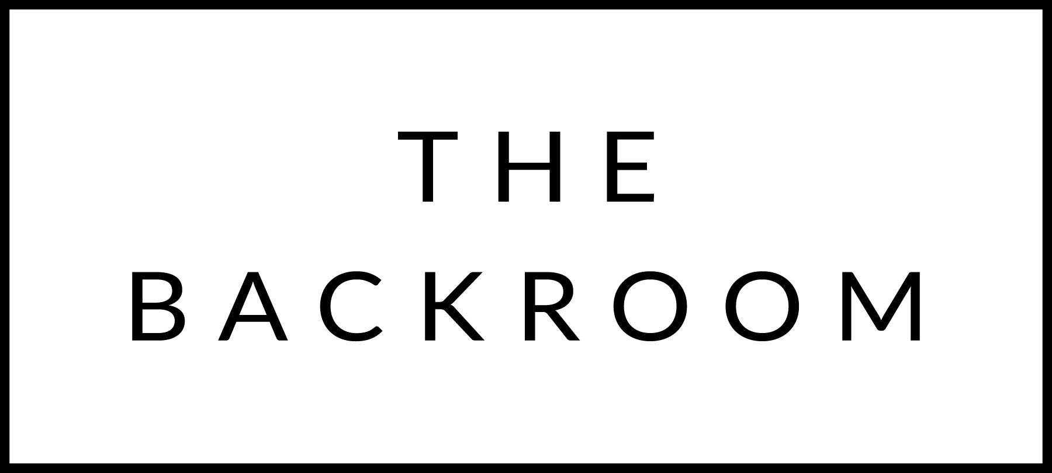

December14th, 2015
Liquid Art Holiday Party!!!

COCKTAIL HOUR SNACKS
Beer & Cheddar Fondue
Gherkins, Pickled Onions,
Roasted Broccoli, Summer Sausage

TO START
Butternut & Hubbard Squash Soup
Spicy Seeds

PASTA
Chitarra & Lamb Ragu
Yogurt, Herbs

THE MAIN EVENT
Roasted Pork Tenderloin
Creamy Polenta, Quince & Smoked Maple Glaze

FOR THE TABLE
Cider Jelly Glazed Brussels Sprouts

DESSERT
Chocolate-Hazelnut Cake
Earl Grey Ice Cream

