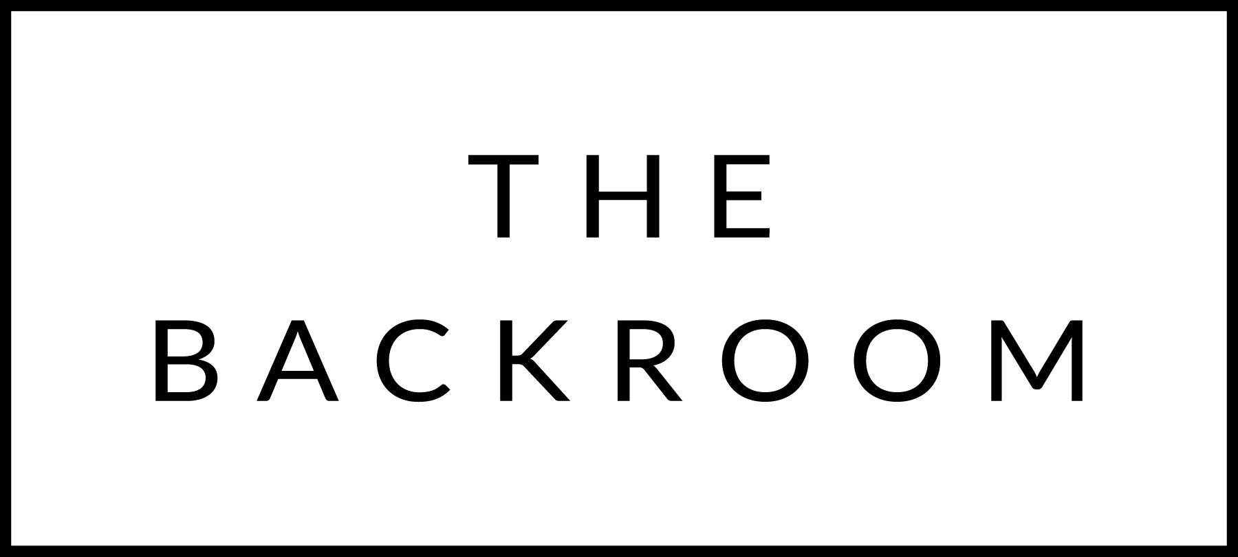

December 14th-16th, 2018

COCKTAIL HOUR SNACKS
Escargot, Lemon Butter
Shrimp Toast
Gouda & Dill Arancini
Sunchoke Pakora

FIRST
Roasted Squash Soup
Red Curry Shrimp & Toasted Coconut

THE MAIN EVENT
Local Rib Eye
Fingerling Potatoes, Soubise
Blue Cheese Butter

FOR THE TABLE
Kimchee Glazed Brussels Sprouts

DESSERT
Maple Cheesecake
Brown Butter Ice Cream

