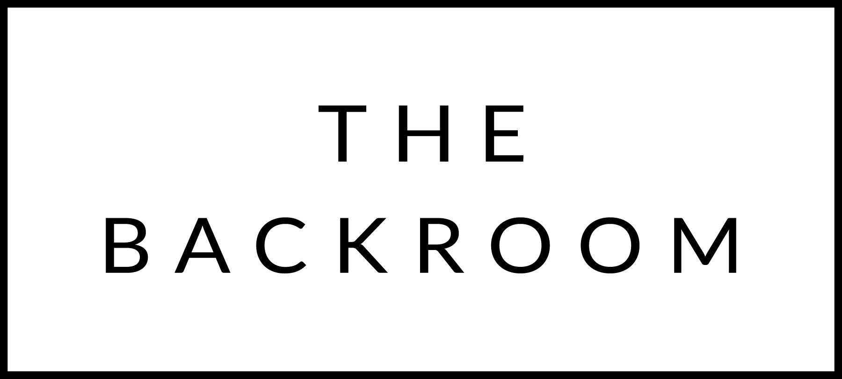

January 8th & 9th, 2016

COCKTAIL HOUR SNACKS
Lettuce Wraps
Pork Belly, Braised Lamb Shank, Smoked Trout
Cured Radishes & Pickled Cucumber
Maple Hoisin, Cucumber Yogurt

TO START
Beet Cured Gravlax
Rye, Wasabi Tobiko, Crème Fraiche

THE MAIN EVENT
24 HR Brisket
Brussels Sprout & Horseradish Slaw

FOR THE TABLE
Ricotta Gnocchi
Brown Butter, Parmesan & Herbs

DESSERT
Olive Oil Cake
Ginger Ice Cream, Candied Citrus

