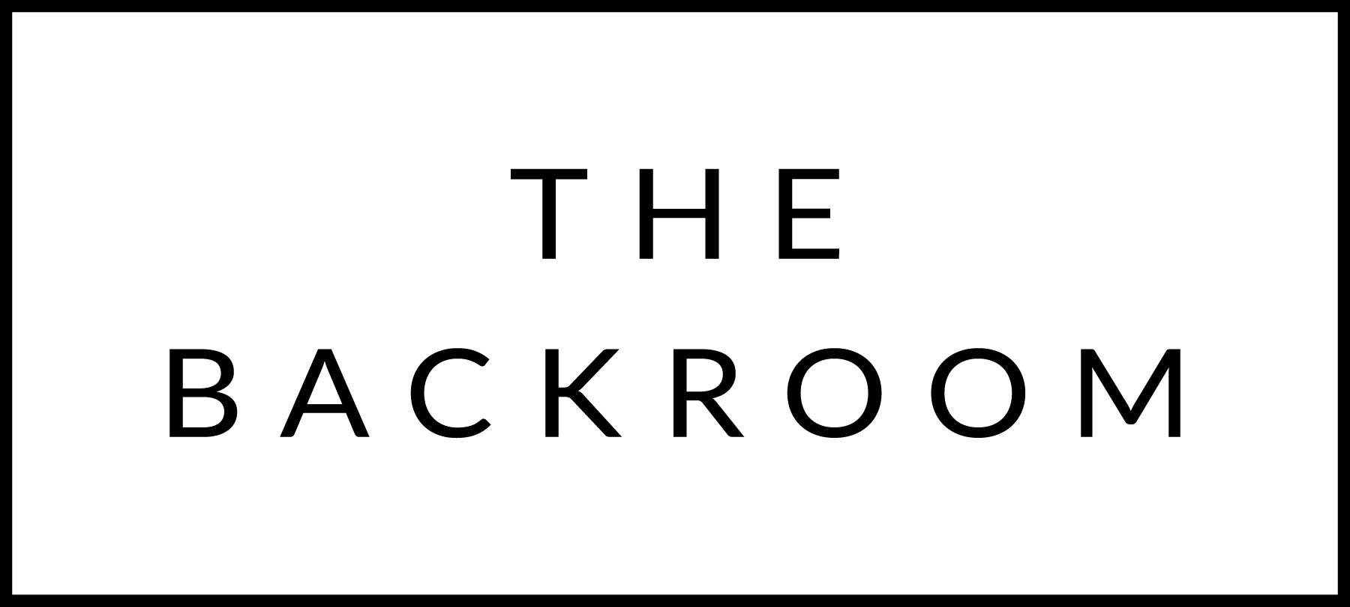

December 16th & 17th 2016
Happy Holidays!!

COCKTAIL HOUR SNACKS
Cloth Bound Cheddar Pimento Dip
Crab Dip, All Souls Chips
Baked Brie & Cranberry Mostarda

FIRST
Kale & Farro Salad
Spiced Seeds, Pickled Onions
Tahini-Avocado Dressing

THE MAIN EVENT
Native Pork Loin
Sweet Potato, Dates
Coriander & Herb Brown Butter

FOR THE TABLE
Shaved Brussels Sprouts
Fig Vincotto

DESSERT
Vanilla Buttermilk Panna Cotta
Chai Poached Pears, Oat Cookie Crumble

