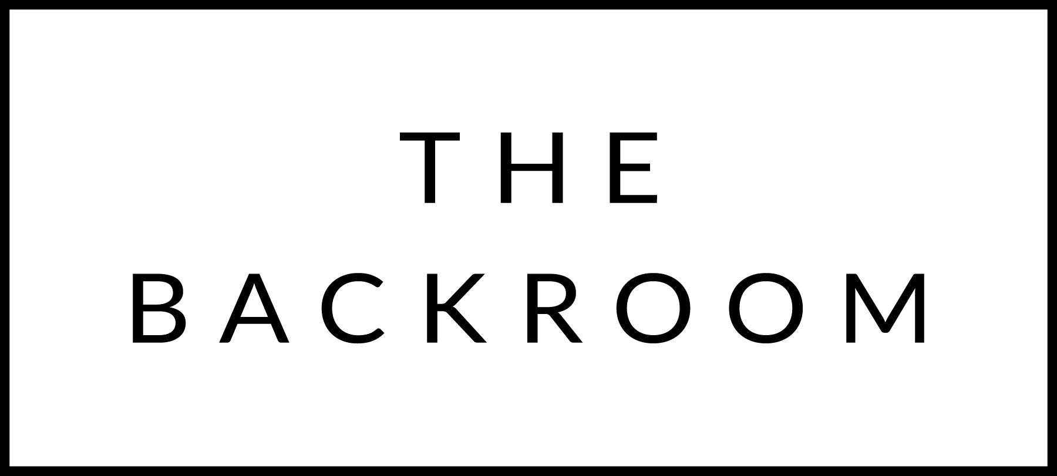

December 23rd, 2017
Happy Holidays

COCKTAIL HOUR SNACKS
Beausoleil Oysters
Lobster & Apple Summer Rolls
Nantucket Bay Scallops, Yuzu Butter
Monkfish Liver

FIRST
Sunflower Seed Risotto
Black Truffle, Kohlrabi, Parmesan

THE MAIN EVENT
Local Beef Wellington
Porcini & Foie Gras Emulsion
FOR THE TABLE
Kale Amandine

DESSERT
Halva Bread Pudding
Goat Cheese Ice Cream

