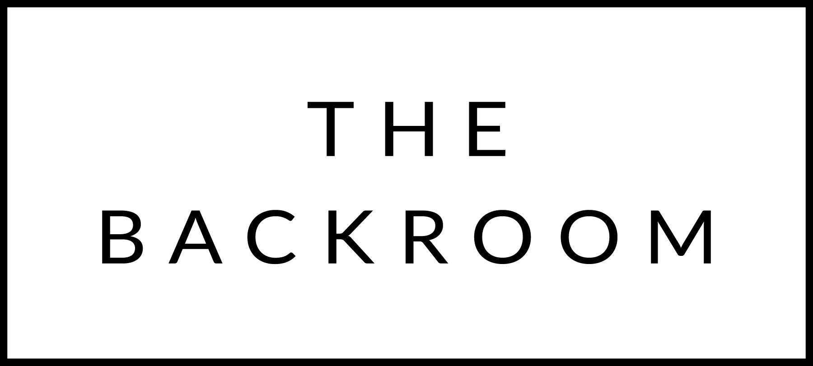

COCKTAIL HOUR SNACKS

Spring Brook Cheese Fondue
Broccoli, Potatoes, Summer Sausage
Gherkins

FIRST
Farro Pizzichi
Cabbage, Caraway, Creme Fraiche
Mustard Crumbs

THE MAIN EVENT
Native Pork Loin
Sweet Potato, Dates
Coriander & Herb Brown Butter

FOR THE TABLE
Roasted Parsnips
Pomegranate Molasses & Seeds

DESSERT
Honeycrisp Apple Tartlet
Almond Cream, Housemade Caramel

