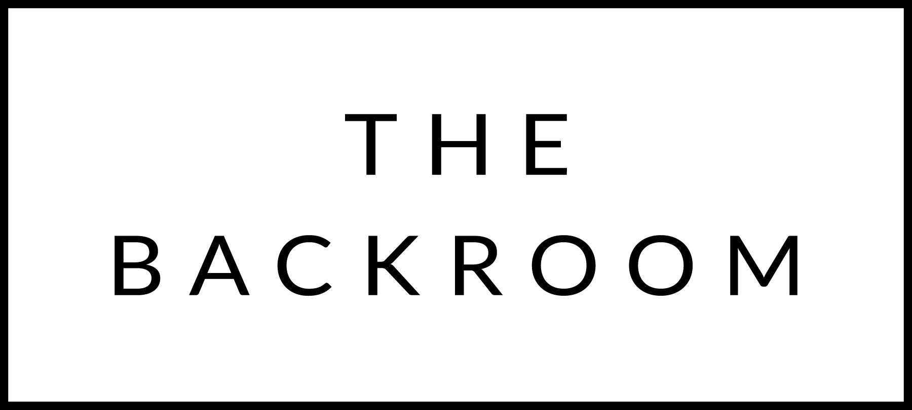

COCKTAIL HOUR SNACKS

Selection of Vermont Charcuterie & Cheeses
Baguette, Gherkins, Homemade Jam

FIRST
Butternut Squash Soup
Maple Foam Spiced Seeds

THE MAIN EVENT
Misty Knoll Chicken Breast
Swiss Chard, Rosti Potatoes
Pomegranate-Walnut Glaze

FOR THE TABLE
Creamed Cabbage
Gherkins, Raclette, Truffle Oil

DESSERT
Chocolate Cake
Toasted Coconut Ice Cream

