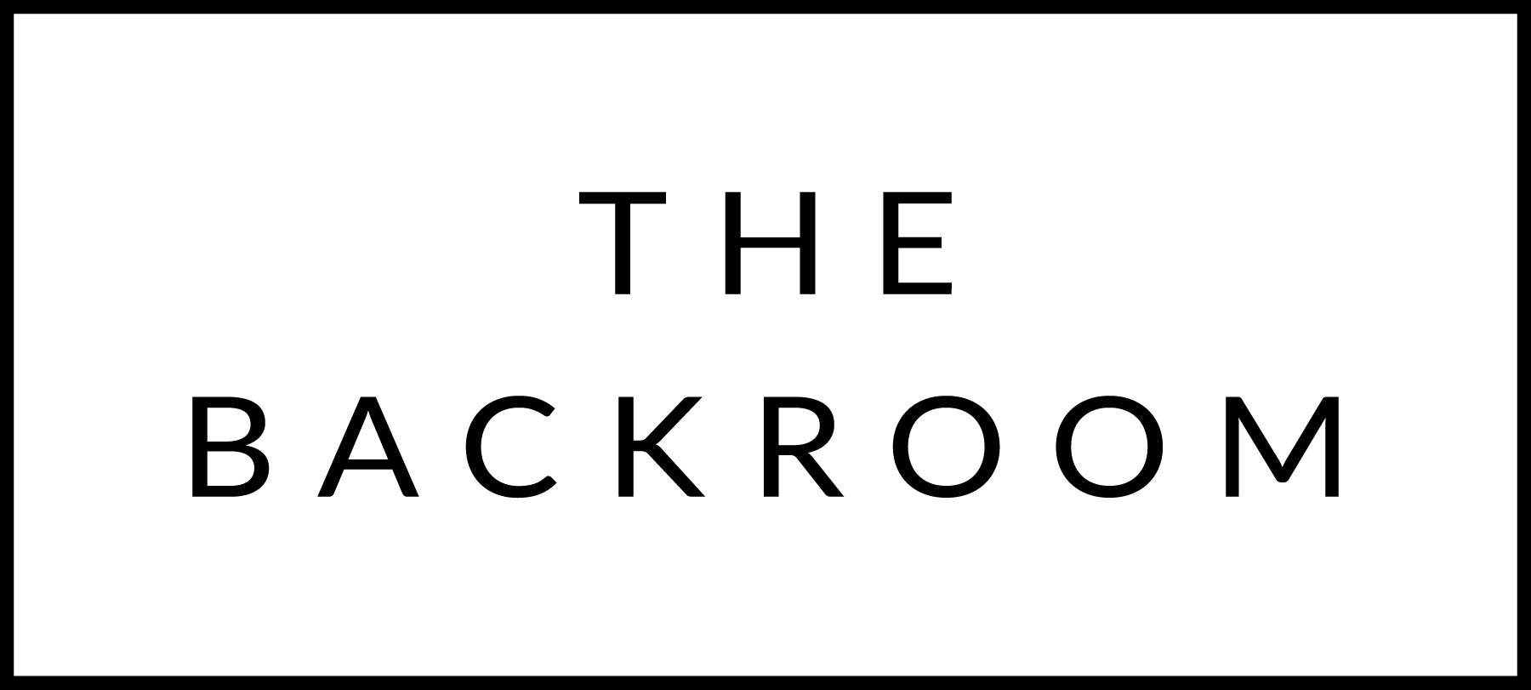

COCKTAIL HOUR SNACKS

Spicy Steak Tartare
Spring Brook Cheese Fondue
Broccoli, Potatoes, Sausage, Gherkins

FIRST
Butternut Squash Risotto
Spicy Seeds, Prosciutto, Pomegranate Molasses

THE MAIN EVENT
Misty Knoll Chicken Breast
Couscous, Brussels Sprouts, Rhubarb Chutney

FOR THE TABLE
Spinach Almondine

DESSERT
Chocolate Ganache
Pistachio Ice Cream, Cocoa Nibs

