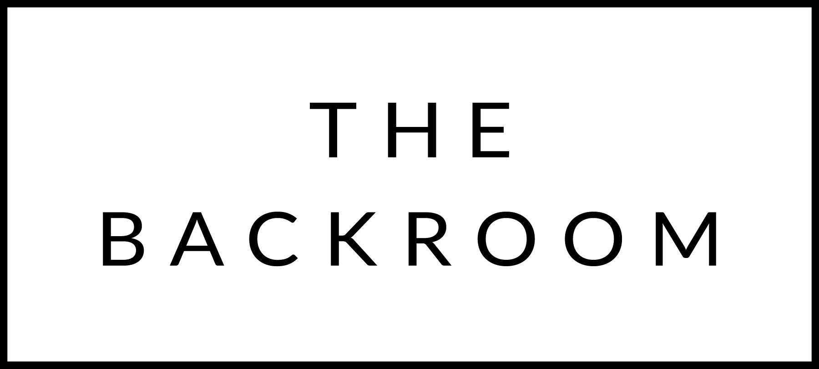

December 4th & 5th, 2015

COCKTAIL HOUR SNACKS
Bayley Hazen Blue, Pear & Prosciutto Toast
Prosciutto Wrapped Sweetbreads
Ricotta & Pomegranate Toast
Black Truffle Croquettes

TO START
Farro Penne Rigate
Cabbage, Crème Fraiche & Bacon

THE MAIN EVENT
Boyden Farms Ribeye
Roasted Roots & Saba

FOR THE TABLE
Butternut Squash Rigatoncini & Cheese

DESSERT
Chocolate-Hazlenut Cake
Banana-Yogurt Ice Cream

