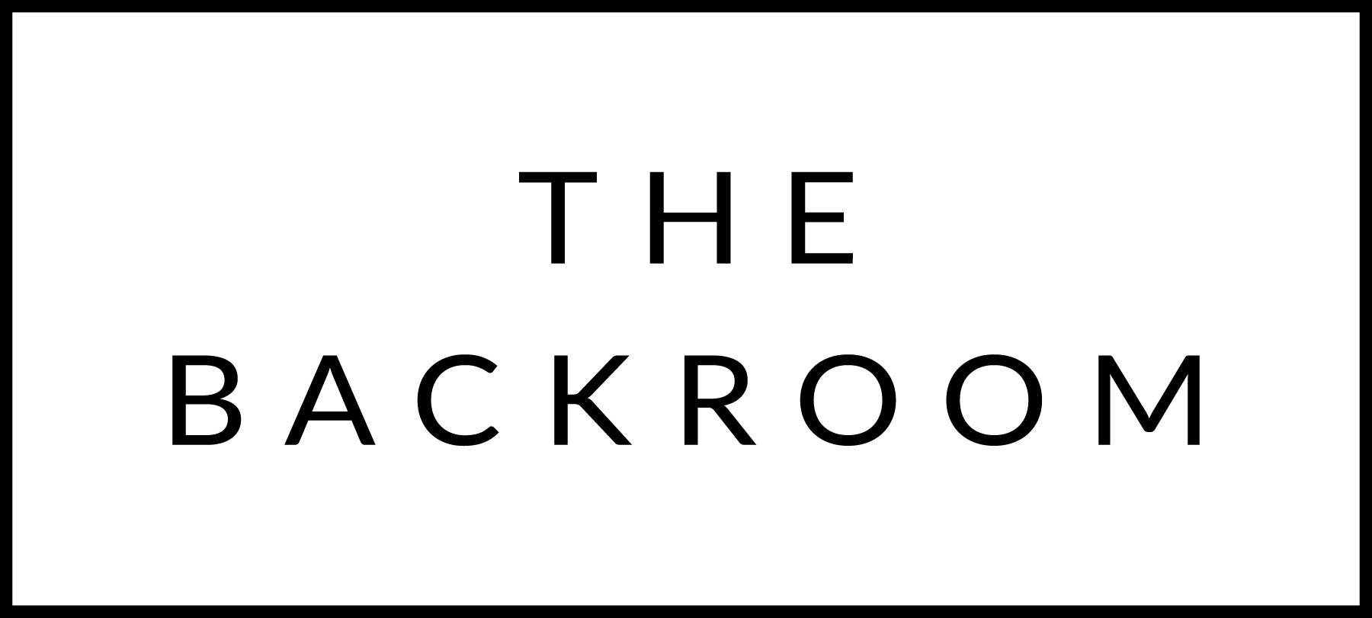

January 27th-29th, 2017

**COCKTAIL HOUR SNACKS**

Black Truffle Croquettes

Maple Miso Glazed Bacon

Salmon Tartar

Wellfleet & Beausoleil Oysters

**FIRST**

Artisanal Trofie

Butternut Squash, Brussels Sprouts, Candied Walnuts, Bayley Hazen Blue

**THE MAIN EVENT**

Misty Knoll Chicken

Crushed Celery Root, Swiss Chard

Castelvetrano Charmoula

**FOR THE TABLE**

Maple Glazed Radishes

**DESSERT**

Lemon Pudding Cake

Blood Orange-Cardamom Ice Cream