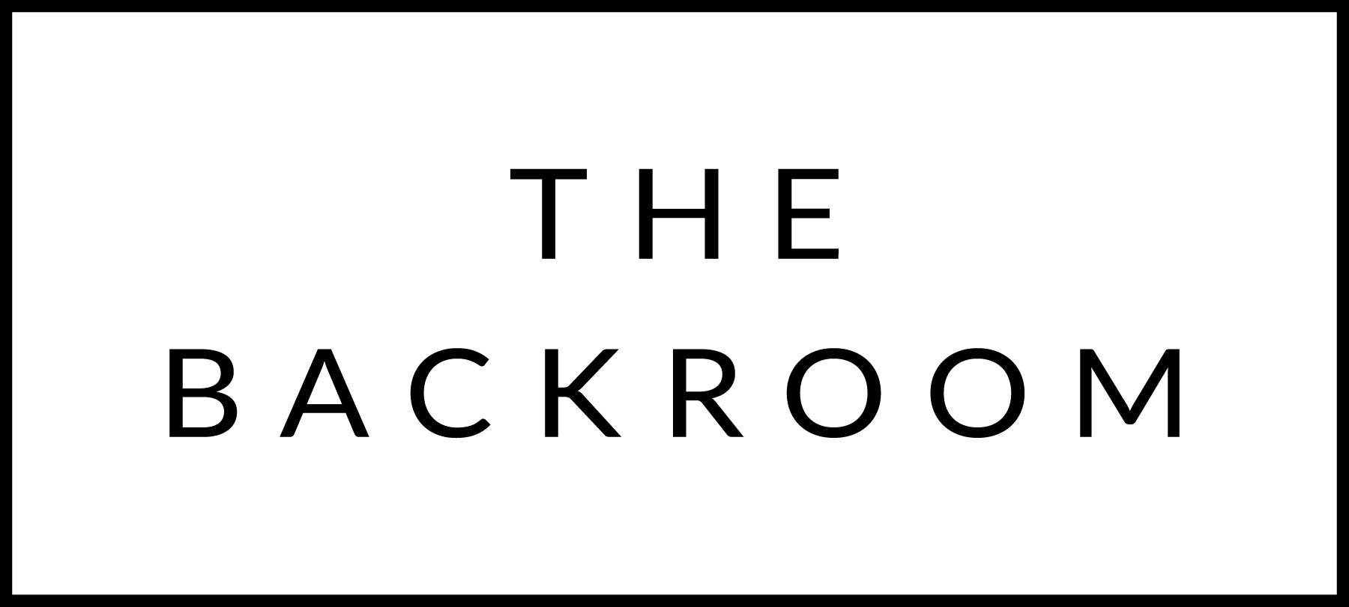

January 29th & 30th, 2016

COCKTAIL HOUR SNACKS
Ricotta Meatballs
&
Randall Steak Tartar

TO START
Farro Paccherini
Celery Root, Pancetta & Escarole

THE MAIN EVENT
Newhall Farm Randall Beef
Sweet Potato & Brussels Sprout
Red Wine-Balsamic Onions

FOR THE TABLE
Sunchoke & Leek Gratin
Spicy Crumbs

DESSERT
Malted Dark Chocolate Cake
Buttermilk Ice Cream

