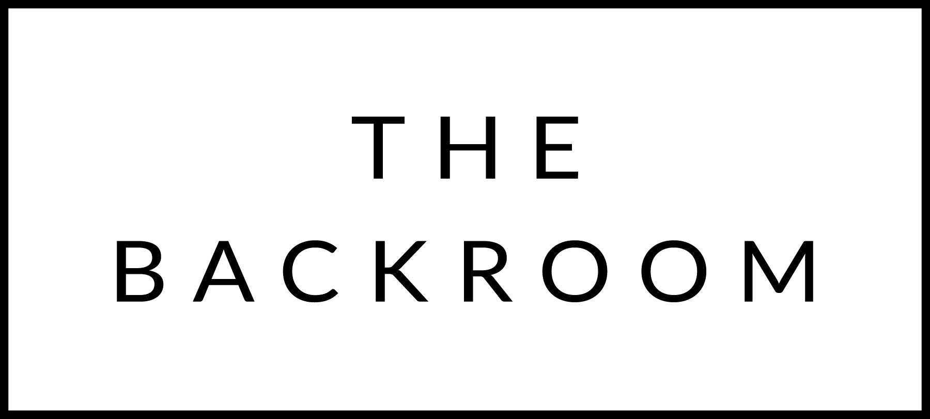

December 9th & 10th, 2022
Welcome Back!

COCKTAIL HOUR SNACKS
Jasper Hill Willoughby Broccoli Dip
Smoked Trout Dip
Korean Steak Tartar
House Chips

TO START
Bucatini all’Amatriciana
‘Nduja, Prosciutto & Parmesan

THE MAIN EVENT
Boyden Farms Ribeye
Sweet Potato & Shallot-Black Bean Sauce

FOR THE TABLE
Roasted Brussels Sprouts
Soy-Maple Butter

DESSERT
Apple Almond Tart
Apple Jam, Cinnamon Ice Cream

