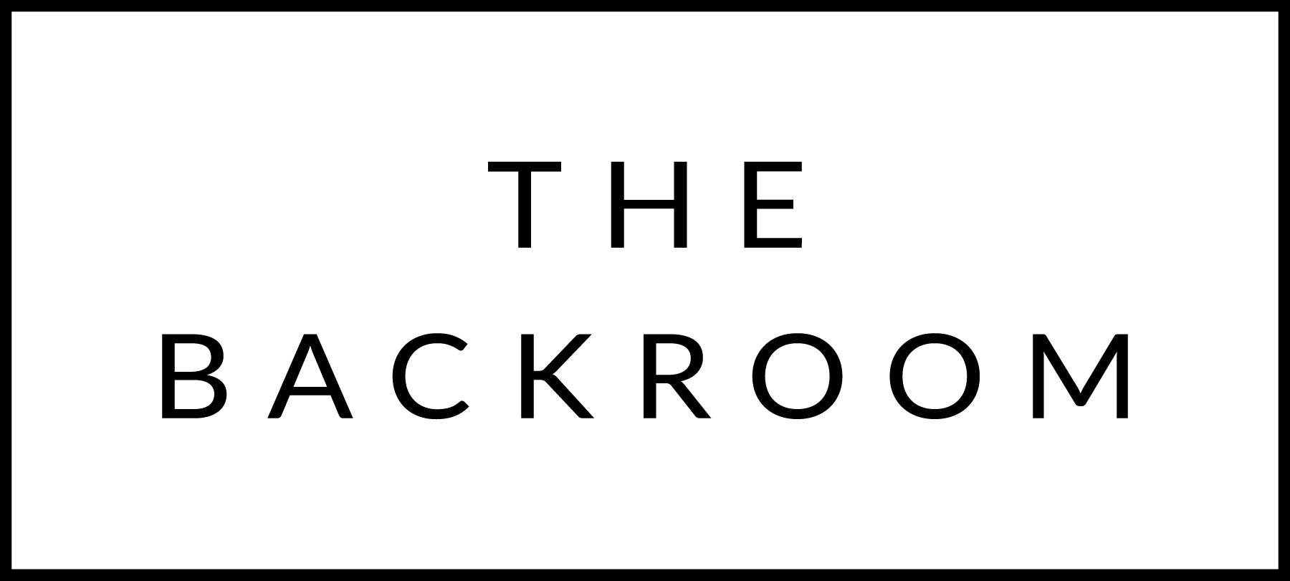

January 6th to 8th, 2016

COCKTAIL HOUR SNACKS
Baked Blythedale Brie, Strawberry-Rhubarb Jam
Hamachi Tartar, Ponzu Radish & Scallion
Smoked Venison Loin, Lingonberry Crème Fraiche

FIRST
Basmati Rice Bowl
Braised Cabbage, Pickled Maitake

THE MAIN EVENT
Maple Wind Pork Loin
Couscous, Brussels Sprouts
Rhubarb Chutney

FOR THE TABLE
Roasted Broccoli
Broccoli Stem Aioli

DESSERT
Build your own Sundae Bar
Mascarpone Ice Cream, Salted Caramel, Freshly Baked Shortbread Cookies, Hot Cocoa, Whipped Cream, Cherries, Bruleed Bananas, Peanut Butter Fudge

