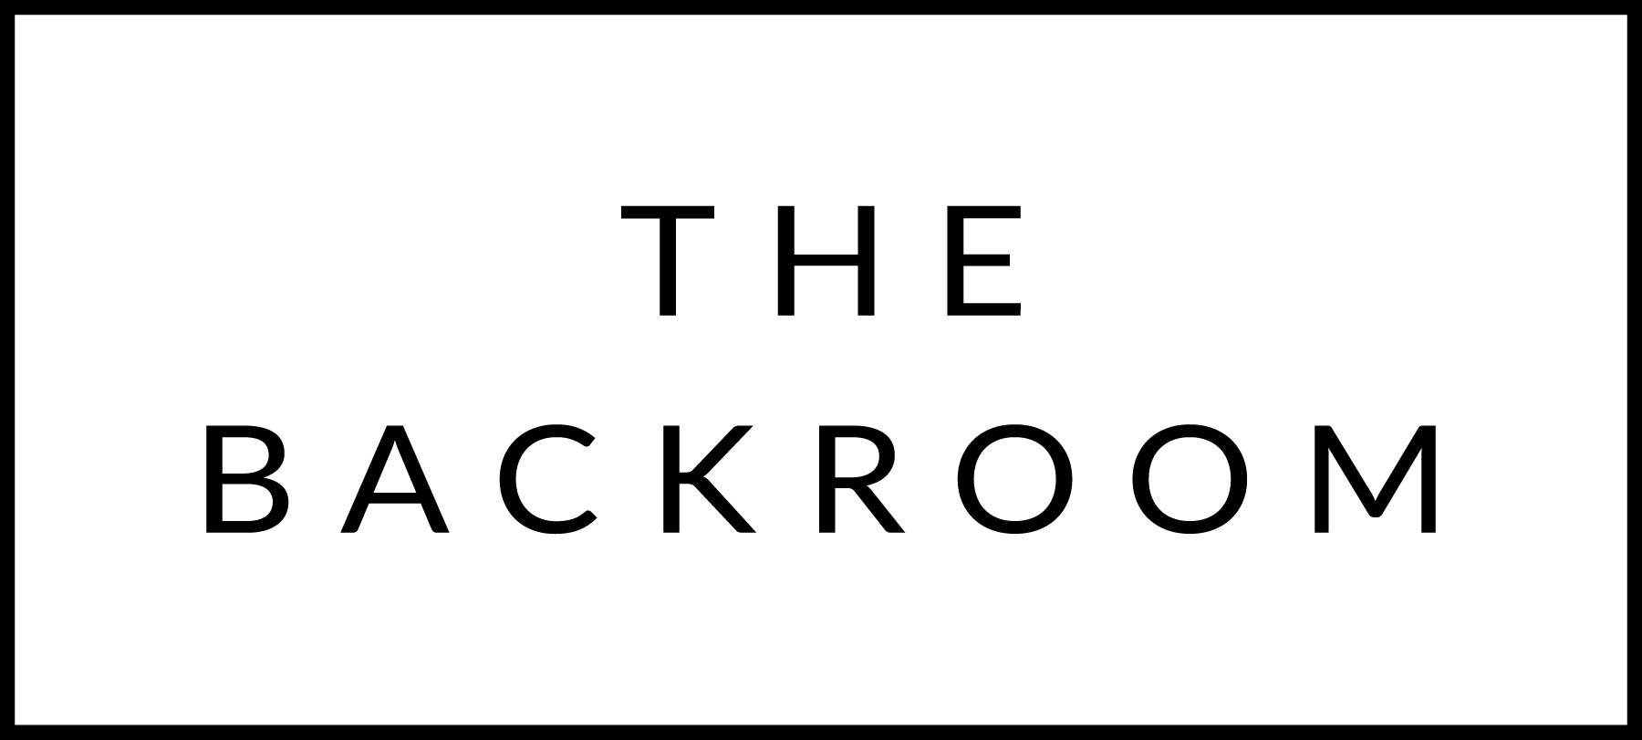

February 12th & 13th, 2016

COCKTAIL HOUR SNACKS
Tarentaise Fondue
Charcuterie, Roasted Broccoli & Peaslee Potatoes

Smoked Lamb Ribs

TO START
Heirloom Bean & Kale Soup
‘Nduja Toast

THE MAIN EVENT
Misty Knoll Chicken
Acorn Squash, Roasted Onions
Porcini-Balsamic

FOR THE TABLE
Barley Risotto
Bayley Hazen Blue

DESSERT
Ice Cream Sandwich
Goat Cheese & Poached Pear Ice Cream,
Rosemary Shortbread & Salted Caramel

