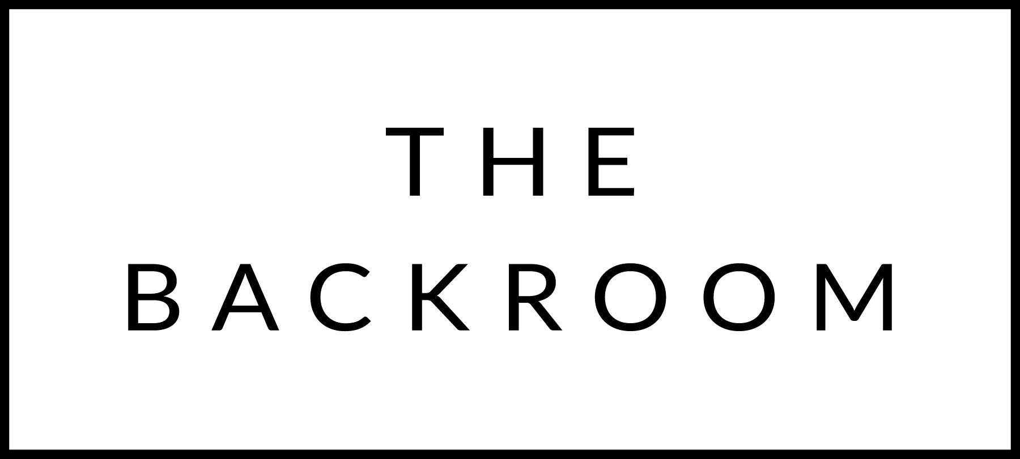

February 17th-18th, 2023

COCKTAIL HOUR SNACKS
Ham & Cheese Croquettes
Crispy Tofu, Jalapeno Dip
Maplebrook Ricotta Toast

TO START
Prince Edward Island Mussels
Wild Garlic, Crème Fraiche
Boundbrook Farm Brown Rice

THE MAIN EVENT
Smothered Pork Chops
Oyster Mushrooms, Whipped Potatoes

FOR THE TABLE
Roasted Brussels Sprouts
Bacon & Chili Butter

DESSERT
Apple Fritter
Sour Cream Ice Cream, Salted Caramel, Candied Oats

