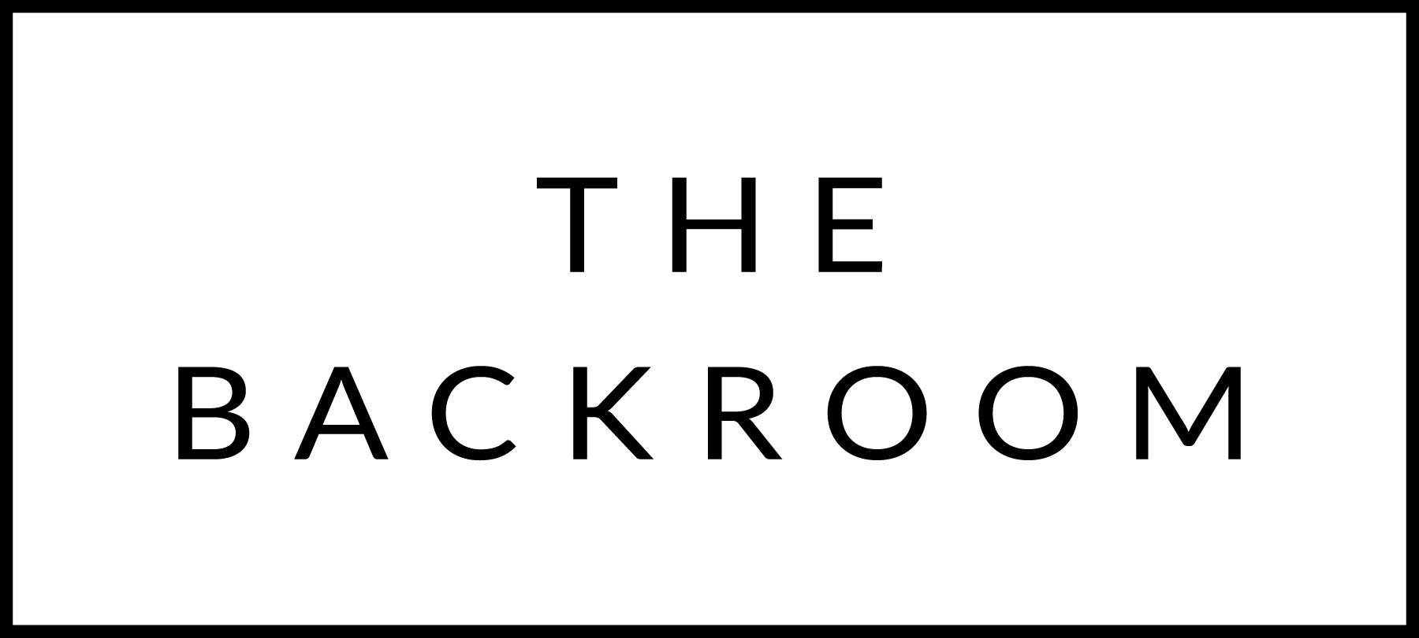

February 18th, 2016
Happy Birthday Colleen!!!!!

COCKTAIL HOUR SNACKS
Selection of Local Charcuterie & Cheese
Duck Live Pate
Uni Toast
Roasted Pork Belly

TO START
Red Trout Toast
Beets, Wasabi Tobiko & Dill

THE MAIN EVENT
Misty Knoll Chicken Schnitzel
Date-Gherkin Brown Butter

FOR THE TABLE
Ricotta Gnocchi
Brussels Sprouts & Leeks

DESSERT
Apple Fritters
Salted Caramel Ice Cream

