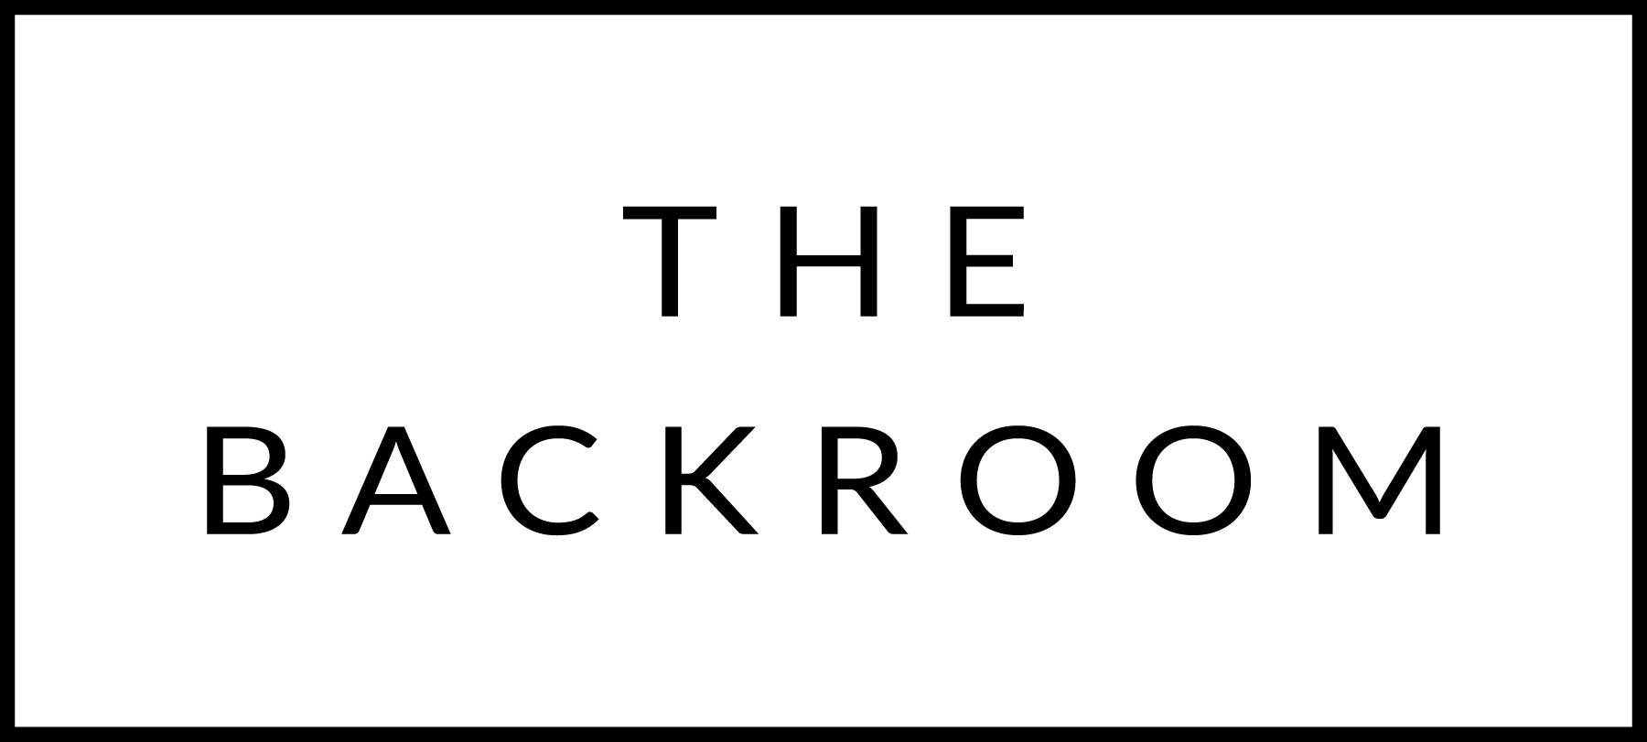

February 18 & 19th, 2016

COCKTAIL HOUR SNACKS
Selection of Local Charcuterie & Cheese
Duck Liver Pate
Crab Toast & Orzo Stuffed Clams

TO START
Red Trout Toast
Beets, Wasabi Tobiko & Dill

THE MAIN EVENT
Roasted Duck Breast
Brussels Sprouts, Dirty Wild Rice
Lingonberry Vinaigrette

FOR THE TABLE
Longpepper & Maple Roasted Carrots

DESSERT
Apple & Tart Cherry Claflouti

