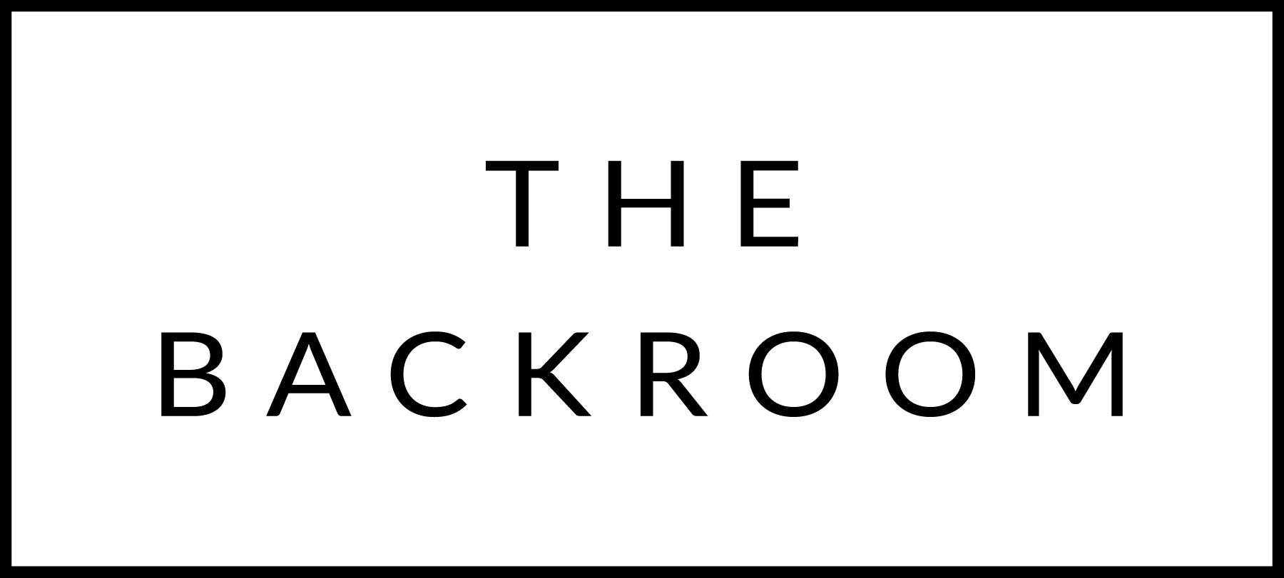

February 9th, 2018

COCKTAIL HOUR SNACKS
Steak Tartar
Black Truffle Croquettes
Blue Cheese Arancini
Rutabaga Tempura

FIRST
Carrot Tonkotsu Ramen
Maple Wind Farms Pork Belly, Scallions & Pickles

THE MAIN EVENT
Roasted Misty Knoll Chicken
Buttercup Squash
Pumpkinseed & Beet Mole
FOR THE TABLE
Shaved Brussels Sprouts, Pancetta, Mimolette Cheese

DESSERT
Mascarpone Cheesecake
Blood Orange

