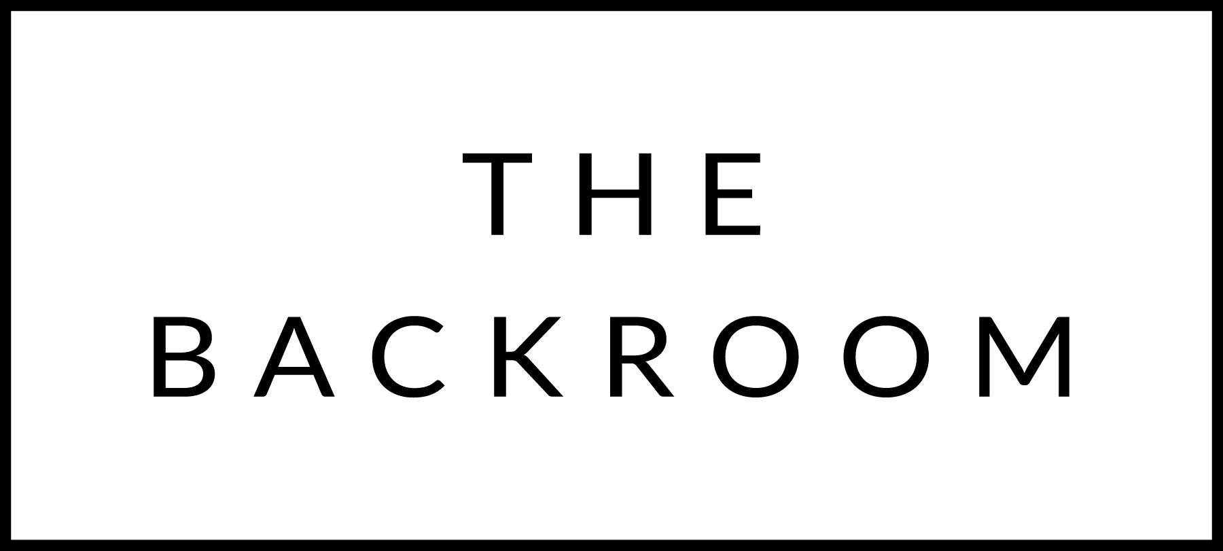

March 10-13th, 2017

COCKTAIL HOUR SNACKS
Piadina
Charmoula, Zucchini Hummus, Traditional Hummus
Marinated Littleneck Clams

FIRST
Artisanal Bucatini
Spicy Marinara, Baby Kale, Parmesan

THE MAIN EVENT
Boyden Farm Hanger Steak
Celery Root Mash
House-made Rhubarb Compote

FOR THE TABLE
Sautéed Brussels Sprouts
Lignonberries & Brie

DESSERT
Almond & Orange Cake
Citrus Marmalade, Rosemary Ricotta Ice Cream

