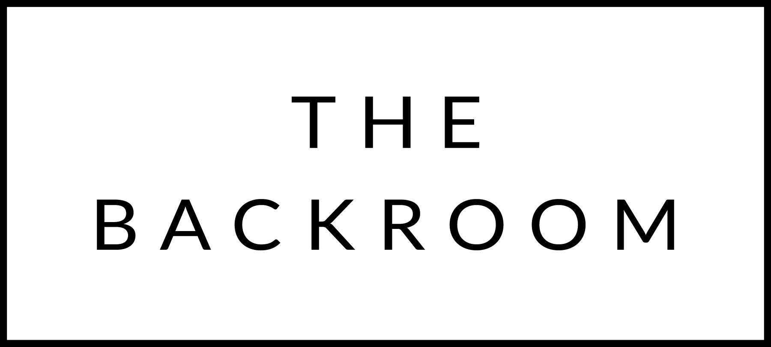

March 4th & 5th, 2016

COCKTAIL HOUR SNACKS
Maplebrook Burrata
Beef Carpaccio
Uni Toast

TO START
“Good Things” Bolognese
Chitarra Pasta & Oradale Cheese

THE MAIN EVENT
Chatham Cod
Cockles, Orzo & Parsley

FOR THE TABLE
Lacinato Kale
Hazelnut Brown Butter

DESSERT
Dark n’ Stormy
Spiced Rum Cake, Ginger Ice Cream, Lime Curd

