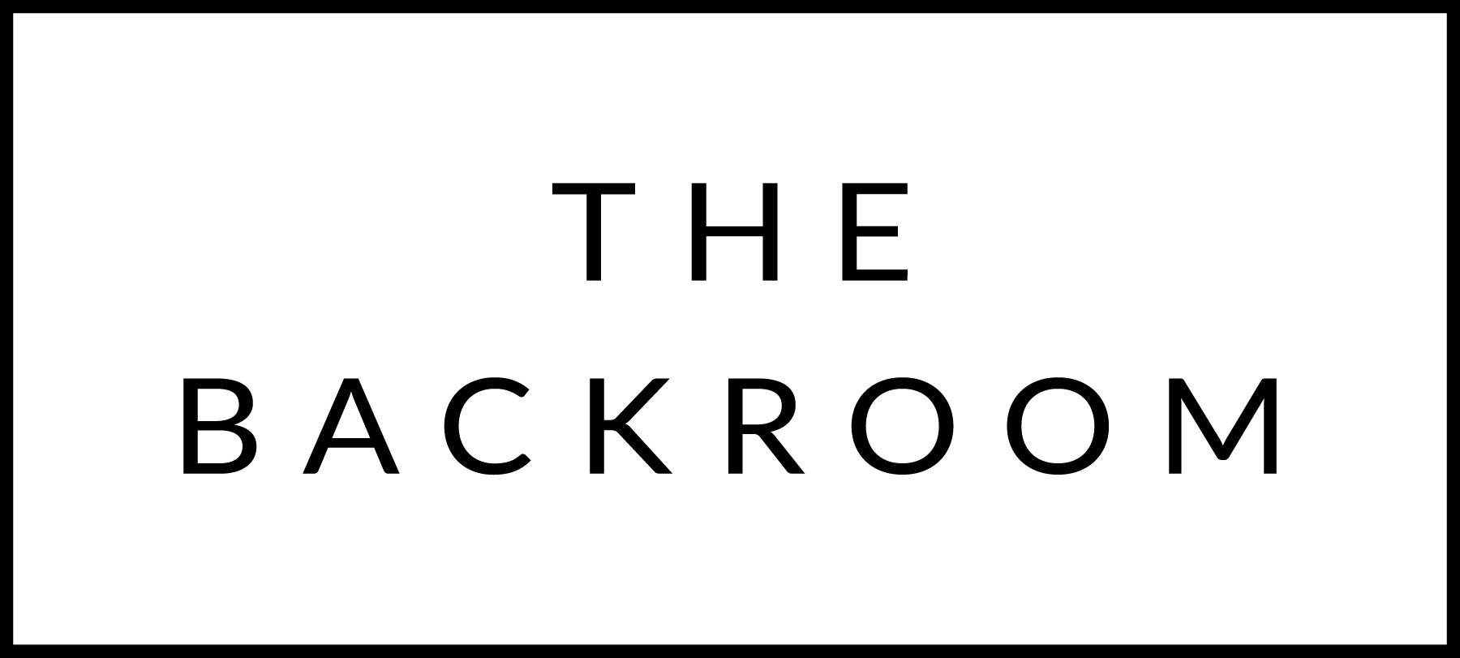

May 1st & 2nd, 2015

COCKTAIL HOUR SNACKS
Jumbo Asparagus
Fresh Lemon, Green Curry Hollandaise
Espelette Pepper, Smoked Salt

FIRST COURSE
Housemade Gnocchi
King Crab, Marrow Buerre Blanc

THE MAIN EVENT
Dry Aged Rib Eye
Asparagus, Ramps, New Potatoes & Mushrooms

FOR THE TABLE
Spring Peas
Bacon Lardons, Tarantaise, Mint

DESSERT
Almond Coconut Cake
Toasted Coconut Frosting

