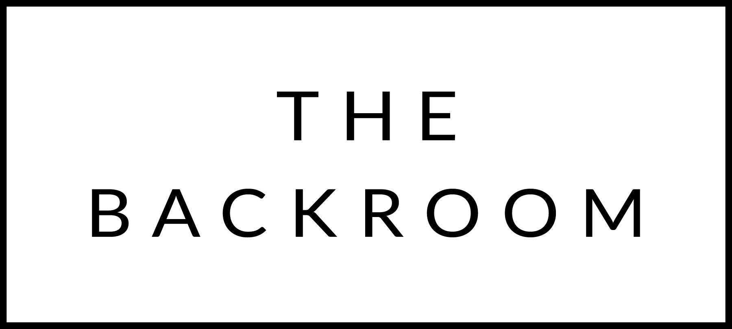

October 1st, 2015

COCKTAIL HOUR SNACKS
Mini Cheeseburgers
Crispy Artichokes, Smoked Paprika Aioli
Butternut Squash Arancini

FIRST COURSE
Kale & Chorizo Salad
Mustard Seeds, Local Honey & Manchego

THE MAIN EVENT
Port Braised Short Ribs
Pumpkin Risotto, Toasted Seeds

FOR THE TABLE
Wild Mushroom Bread Pudding
Tarentaise Cheese

DESSERT
Spiced Panna Cotta
Cider Gelee, Fresh Cream

