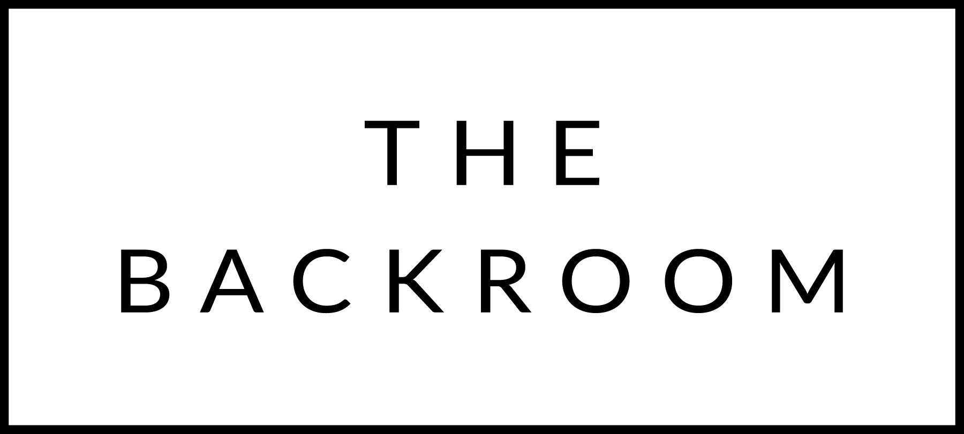

Happy Birthday Kaitlyn!!
October 22nd, 2015

COCKTAIL HOUR SNACKS
Oysters Rockefeller
Chorizo Clams Casino
Butternut Squash Arancini

FIRST COURSE
Sweet Potato Fettuccini
Kale, Almonds, Brown Butter

THE MAIN EVENT
Port Braised Short Ribs
Cauliflower & Golden Raisin Gremolata

FOR THE TABLE
Tamarind-Glazed Delicata Squash

DESSERT
Apple Beignets
Bourbon Ice Cream, Maple Caramel

