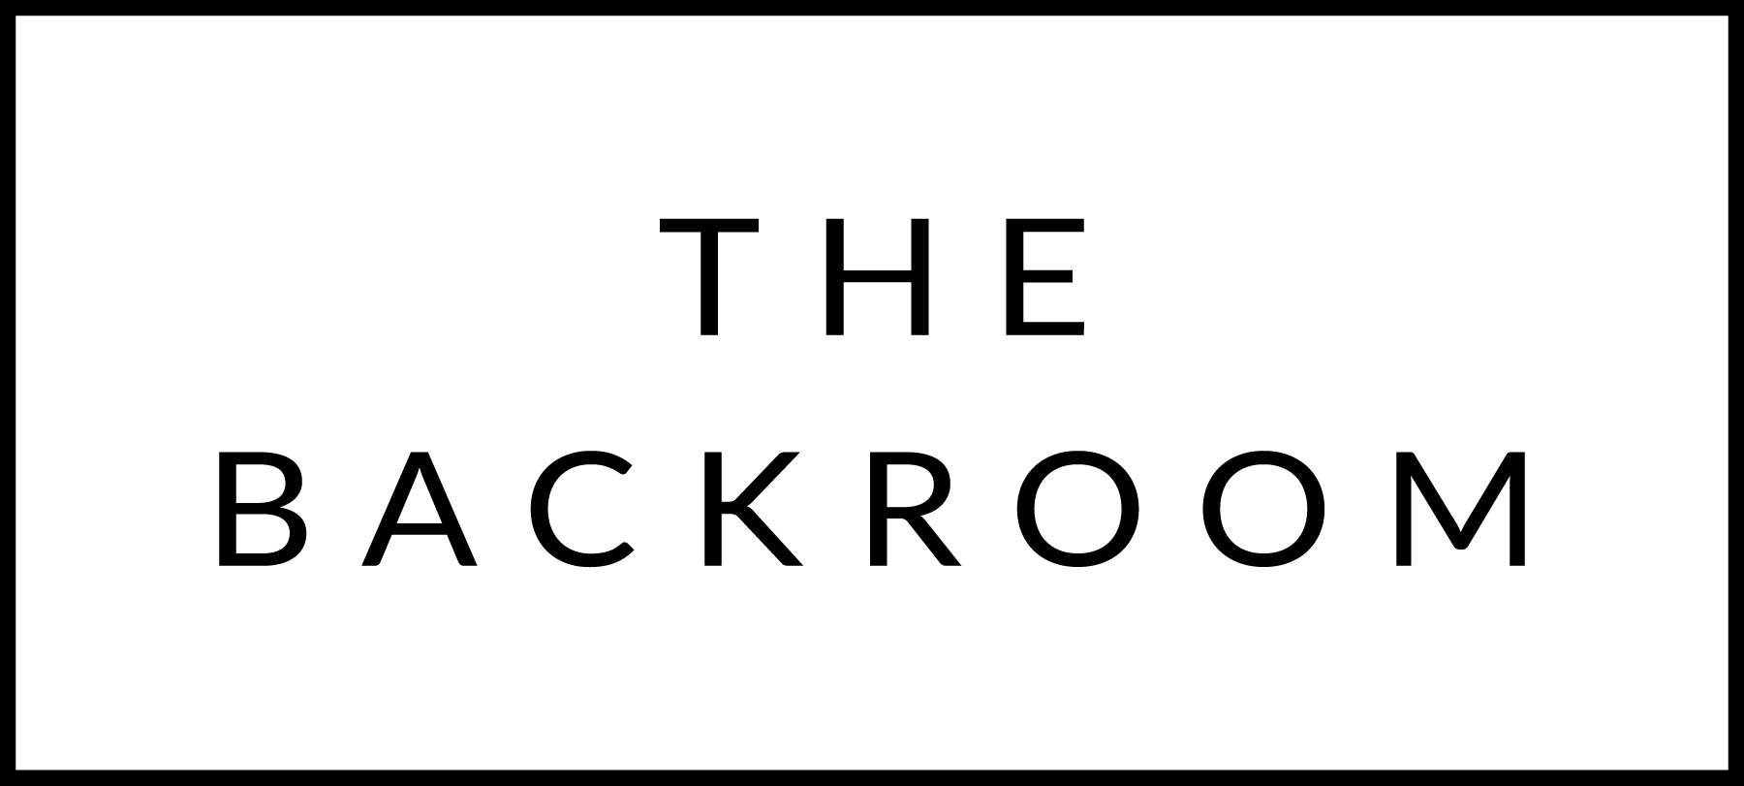

February 27th , 2015

COCKTAIL HOUR SNACKS
Maplebrook Ricotta
Toast, Pomegranite Onions, Fennel Mulberry Jam,
Wasabi Tobiko, Blood Orange & Jalapeno Compote

FIRST
Farro Paccherini
Parmesan, Black Pepper, Smoked Salt
Celery Hearts

THE MAIN EVENT
Slow Roasted Vermont Pork Loin
Cider Braised Savoy & Pickled Mustard Seeds

FOR THE TABLE
Potato Latkes
Rosemary-Apple Sauce , Greek Yogurt

DESSERT
Toffee Pudding Cake
Roasted Empire Apples, 5-Spice Crème Fraiche

