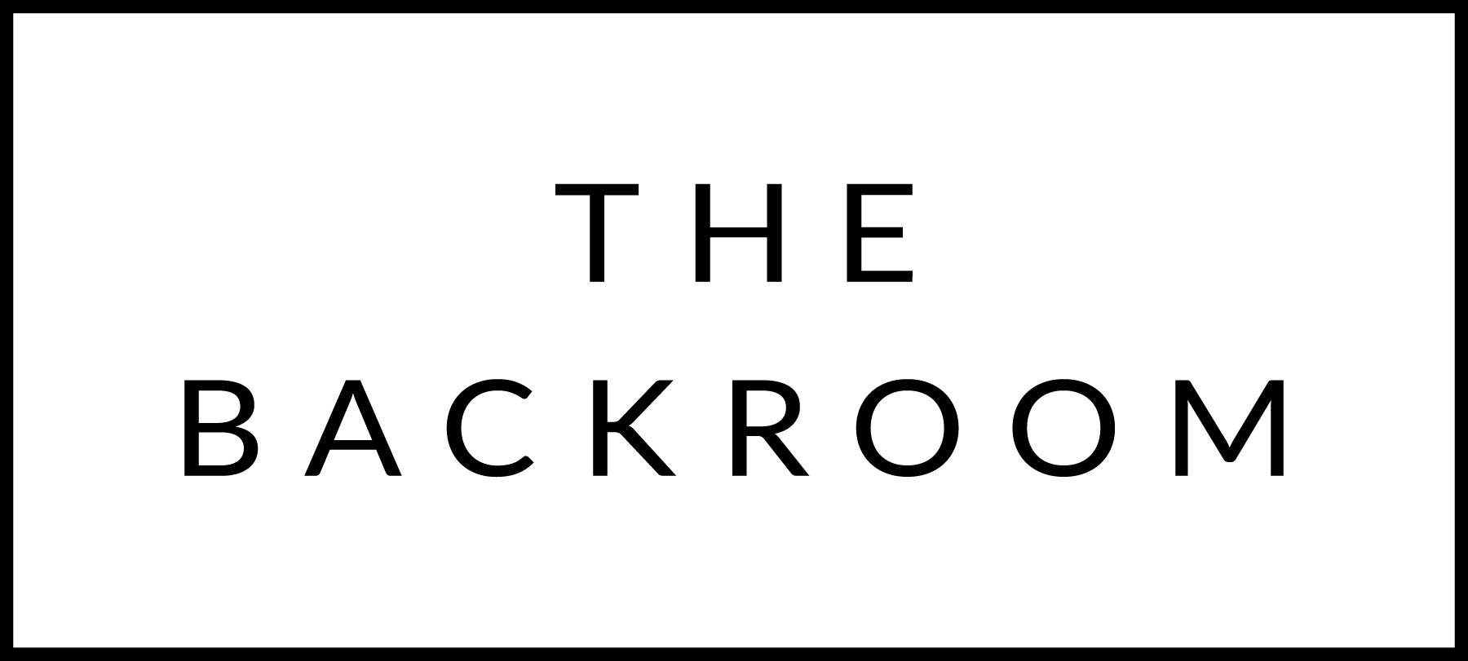

February 5th, 2015

COCKTAIL HOUR SNACKS
Tarentaise Fondue
North Country Sausage, Country Bread,
Gherkins, Roasted Broccoli & Peasleys

FIRST
Northeast Grown BLT Salad
Bayley Hazen Blue, English Muffin Croutons
Green Goddess Dressing

SECOND
Chitarra Pasta
Smoked Salmon, Crème Fraiche & Wasabi Tobiko

THE MAIN EVENT
Porcini Braised Vermont Short Ribs
Nitty Gritty Polenta

FOR THE TABLE
Kale Almondine

DESSERT
Dark Chocolate Mousse
Orange Mascarpone

Thank you for joining us at The Backroom. We would greatly appreciate you providing some feedback on your dining experience tonight by answering the questions below:

What would you consider a “fair” price for this dinner?

Were you comfortable during dinner?

Would you recommend The Backroom to friends?

Did you like the timing/format of the dinner? (ie was it too early?)

Would you consider the alcohol pricing “fair”?

Please provide any additional comments/suggestions/
thoughts below:

Like & Review us on Facebook
Facebook.com/thebackroomvt

Review us on Tripadvisor

