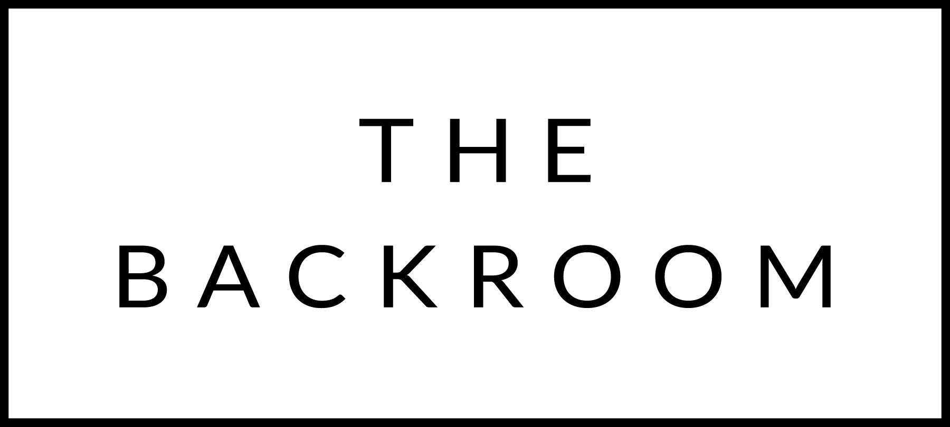

April 24th & 25th, 2015

COCKTAIL HOUR SNACKS
Radishes with Farmhouse Butter
Sea Salt, Smoked Salt & Basil Salt

FIRST COURSE
Maplebrook Ricotta & Toast
Rhubarb-Longpepper Marmalade

MID COURSE
Chitarra Pasta
Foraged Ramps & Pancetta

THE MAIN EVENT
Roasted Misty Knoll Chicken
Watercress & Barley Risotto
Caper Brown Butter

FOR THE TABLE
Roasted Asparagus
Smoked Tomato Hollandaise

DESSERT
Strawberry-Rhubarb Shortcake

