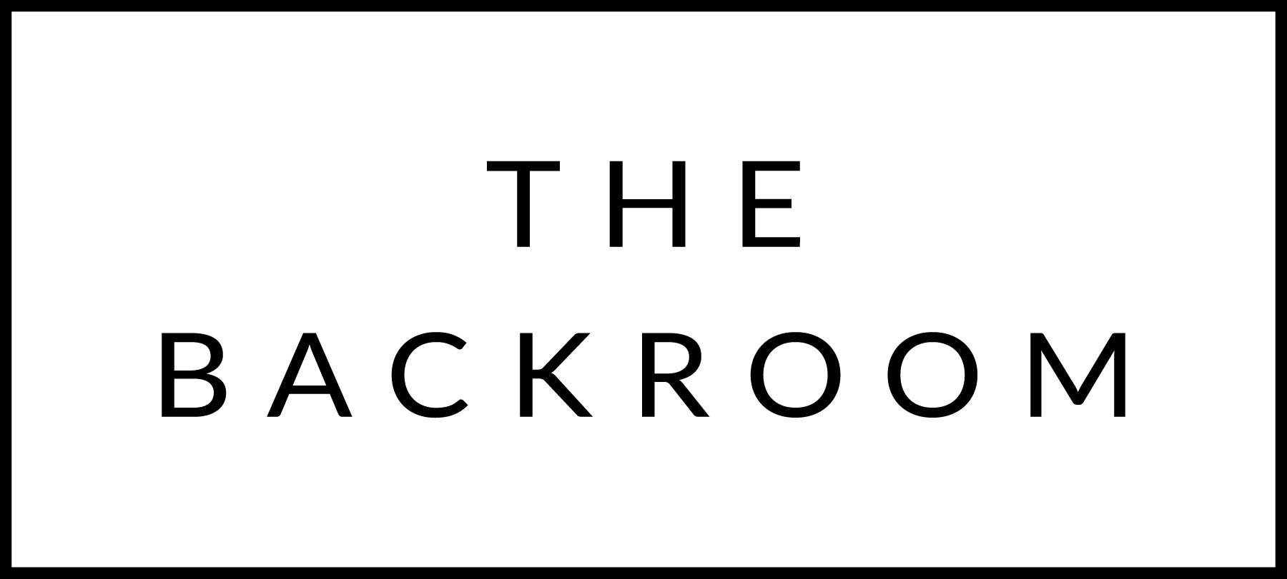

July 10th, 2015

COCKTAIL HOUR SNACKS
PEI Mussels
Red Curry Fra Diavolo

FIRST COURSE
Woods Market Tomatoes & Maplebrook Burrata
Salsa Verde

THE MAIN EVENT
Chatham Diver Scallops
Zucchini Romesco, House-cured Lardo

FOR THE TABLE
Maple & Miso Glazed Bacon
Lovage

DESSERT
Goat Cheese Cheesecake
Local Raspberries, Lemon Balm

