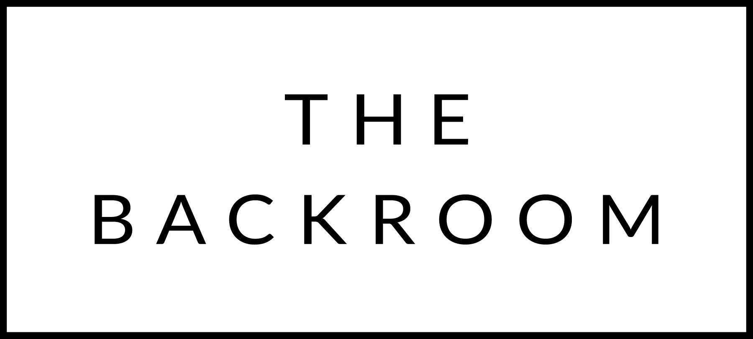

August 23rd, 2015
Happy Birthday, Linda!

COCKTAIL HOUR SNACKS
Selection of Farmstead Cheeses &
Local Charcuterie

FIRST COURSE
Hand Rolled Gnocchi
Summer Corn & Parmesan

THE MAIN EVENT
Boyden Farms Sirloin
Charred Heirloom Tomatoes
Avocado

FOR THE TABLE
Summer Bean Salad
Salsa Verde

DESSERT
Sweet Cream Pavlova
Mixed Berry Compote

