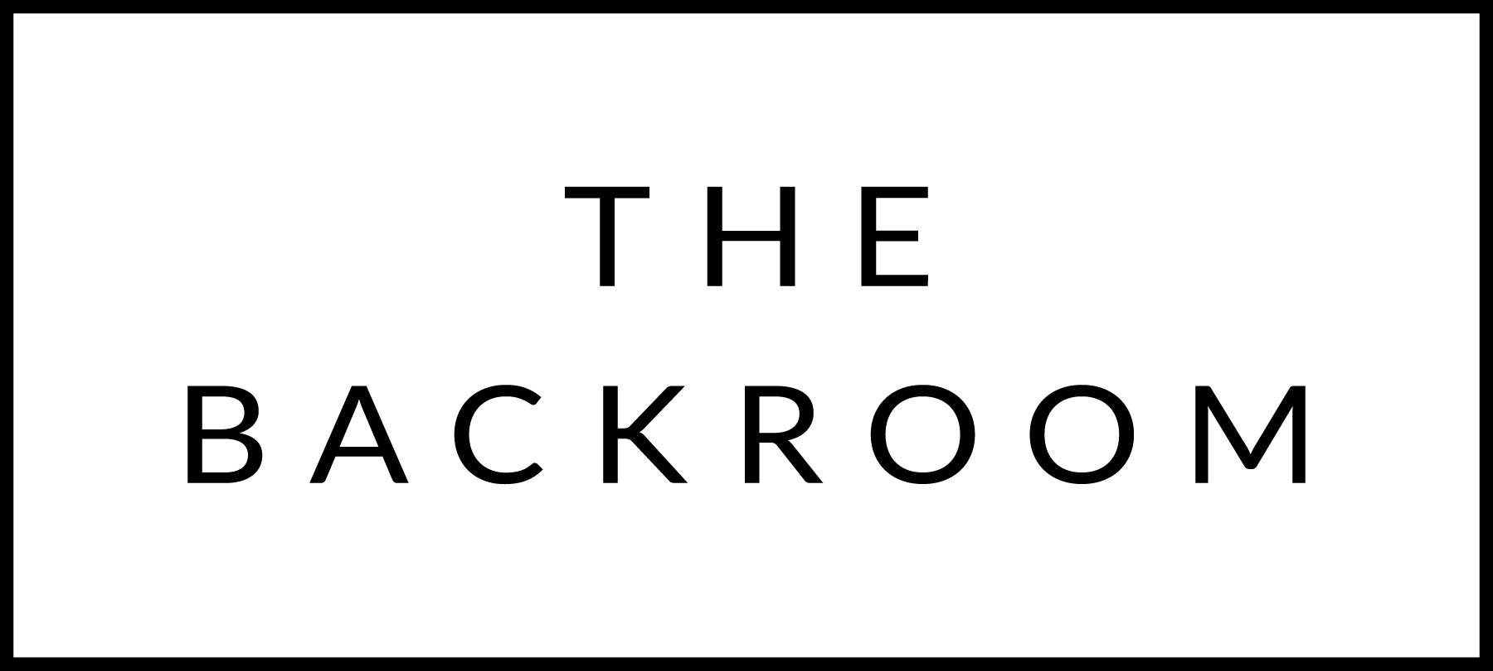

BOTTLED BEER & CIDER

Allagash White: Portland, ME $6

Maine Beer Co. “Peeper” Ale 16 oz
Freeport, ME $12

Longtrail Ale: Woodstock, VT $4

Ommegang Abbey Dubbel
Cooperstown, NY $6

Shed IPA: Middlebury, VT $5

14th Star Maple Breakfast Stout:
St. Albans, VT $8

Switchback Ale: Burlington, VT $6

Naragansett Lager: Naragansett, RI $3

Jack’s Abby, Hoponious Union,
Framingham, MA $6

Citizen Cider Dirty Mayor 16oz
Burlington, VT $8

COCKTAILS
$9

Apple-rol Spritz
An ode to Venice, right here in Pittsfield
Aperol, Lake Champlain Cider, Tonic

Nor’easter
The Backroom’s signature cocktail
Bulleit Bourbon, Local Maple Syrup, Ginger

Fire on the Mountain
Because a cinnamon-y drink and smoke belong in Winter
Smokey Mezcal, Sugar Bob’s Finest Kind Smoked Maple Syrup, Housemade Cinnamon Syrup, Tuaca

Sippin’ on Gin & Spruce
Snoop Dog would be proud
Silo Gin, Hooker Mountain Spruce Soda

Pom and Circumstance
Because, girl, you fancy
Pomegranate, Green Mountain Vodka

Apple Martinez
Father to the Martini, this cocktail is dignified and delicious
Old Tom Gin, Newhall Ice Cider, Carpano Antica

